October 13, 2019
28th Sunday in Ordinary Time
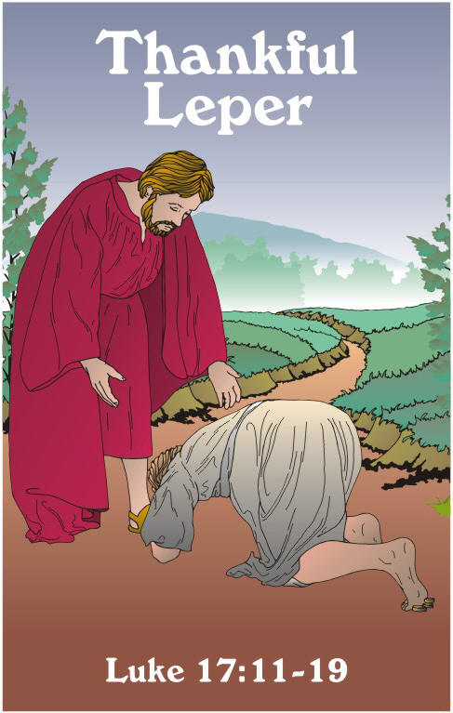
In today’s Gospel we see Jesus curing ten lepers but only one – a Samaritan – came back to thank Him. We believe the same Lord continues through the centuries to bring healing to people of faith. We pray for our brothers and sisters who are anointed this weekend. We pray that they find in Jesus the strength to carry the Cross with Him.

Today we celebrate the Sacrament of the Anointing of the Sick (at all Masses) for the senior and ill members of our parish family. When a member of the family suffers all the members support and care for them. We believe the Lord Jesus continues to suffer in the sick members of His Body.

BREAKFAST BUFFET
8:00AM TO 12:45PM
Sunday February 10, 2019
$9/Adults ~ $4/Children under 12

Leave the cooking to our Breakfast Crew for an all you care to eat Buffet on the 2nd Sunday of the month (except August). Each month we cook up a full buffet of breakfast faire, add a special dish or two and serve it up in a warm and festive atmosphere. Join Us!

The Offertory Collection for the weekend of 9/29 was $4,297.00 and the on-line collection was $1,265.00 for a total of $5,562.00. Thank You.

October is the Month of the Holy Rosary

CHRISTOPHER COUNCIL'S ANNUAL OKTOBERFEST PARTY OCTOBER 19
Enjoy an amazing night of fun entertainment from 6:00 -11:00 PM (doors open at 5:30) Authentic German Band and Dancers will open the evening and play traditional German music complemented with German dancers in Oktoberfest costumes, Swiss horns and all of the Oktoberfest fun! Later in the evening a DJ play a wide selection of modern dance music for your dancing pleasure. Enjoy a German themed buffet with Oktoberfest beer and wine. There is a cash bar for alcoholic beverages and our famous "Schnapps Bar". Tickets are $35. Contact Raymond Cobb for tickets at (302) 547-6931 or at raymondcobb3182@gmail.com

ST. HELENA’S PARISH EXPENSES
In the month of September our parish paid 62 bills totaling $54,822.87! Included were:
$1500 for trash removal (3 months)
$18,750 for our diocesan assessment (3rd quarter)
$2,899.07 for Delmarva Power
$967.96 for Rectory Copier expenses (for 2 quarters of the year).
$5,325.00 for Health Care.
$952.93 for Water Treatment –Boiler
$1120 for visiting priests assisting with Masses.
Also additionally, 25,698.14 for salaries (6 full time and 6 part time).

THE RUSSIANS ARE COMING (AGAIN)!
St. Helena’s will once again host the Russian choir LYRA in concert at 7:00 on Thursday, October 17, 2019. LYRA is a small choir from St. Petersburg, Russia, which travels to the US each year to tour and perform. They sing music from the Russian Orthodox Church and Russian folk music. Anyone who has heard them in prior visits will mark your calendars to hear them again. Those who have missed this great group in prior years should treat yourselves to a special night of music and international fellowship. Bring your friends and neighbors! There is no charge but a free will collection will be taken to help defray travel expenses. For information call (302) 753-5312. Page 1—311

Every Thursday Evening
In Masci Hall
Doors open at 5:30pm
Games begin at 7:00pm
Cookie Jar, Door Prizes, Food!

YOUNG AT HEART

Our next general meeting will be held on Monday, Oct 21 at 7pm in Masci Hall. A travel show, on video, will be presented by Manny Velez. Manny will talk about his recent trip to Russia. Please plan to join us and bring your friends. Tasty refreshments will be served. See you there!
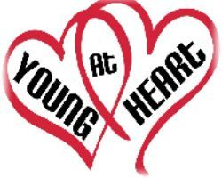

PRAYER SHAWL MINISTRY
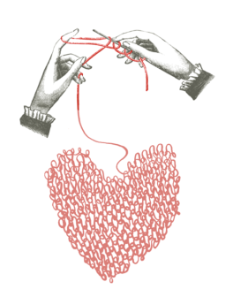

Our next meeting is Oct 9, at 7pm. We meet on the second and fourth Wednesday of each month. We begin our evening with the Chaplet of Divine Mercy or the Rosary. Members and friends donate home-made items for those in need of prayers and comfort. Material is available at no cost and many members create items conveniently at home. You are invited to join our group. Anyone interested in learning to knit and crochet can join our program. Call Dolly, 302-764-3465 or Carmela, 302-762-9057 for further information.

RELIGIOUS EDUCATION

Religious Ed classes will be held this Monday (Oct 14)

1stRECONCILIATION: A Parent/child meeting will be, Sunday, October 27th at 12:15 pm in Masci Hall. This is the only meeting where a parent is asked to attend.

TRUNK or TREAT: October 27 (Sunday) from 6pm to 7:30pm in Masci Hall. Come and join the games inside. Children through 6th grade are invited to attend. Don’t miss this opportunity to mingle with other parishioners.

ADULT SCRIPTURE
Our Bible Study group will be starting the book of Isaiah on November 4. It meets the same time as Religious Education, 6:30 to 7:45 Mondays. All materials are provided without charge, and no Bible experience is necessary! If you would like to participate, please let the Religious Education Office know so we can order a book for you.

How has Jesus touched you and made you whole? In gratitude, ask Him how He would like you to respond. Could Jesus be calling you to follow him as a priest, sister, brother or deacon? If you think God is calling you to be a priest, religious or deacon, contact Fr. Norm Carroll vocations@cdow.org 302-573-3113 www.vocations@cdow.org

Page 2—311
Please Pray For Our Sick Parishioners
Ruth Bower, Charles Brumbaugh, Patricia Darmanin, Jayne Davenport, Bob Davis, Julia Davis, Gerri Episcopo, Sara Garrison, Sarah Hess, Ella Kirksey, Shirley Kosek, Edward Mebs, Gay Meriggi, Dora Pacitti, Fr. Roy Pollard, Terri Reed, Dorothy Rich, Helen Rupnicki, Kathleen Schauber, Irma Shock, Caitlin Soper, Frank Sullivan, Catherine Thomson, James Whisker, Ann Wilson, Cindy Zych, Anita Tyrawski, Mary Gabel, Alline Da Grossa, Toni Di Lezio, Sister Dorothy Prettyman, Sharon Dean, Janet Szubieolski, Catalina Weddle, Ray Altamuro, Marie Spinden, Jane Parsons, Bill Hufnell, Morgan Medeiros, Friends at the Kutz Home, Amy Jo Schosie-Jones, Nicolas Childs

WEEKLY CALENDAR
Sunday, October 13
2nd Collection: Parish Social Ministry
8:00am Second Sunday Breakfast-Masci Hall
11:00am Children’s Lit/Word - Church
Anointing of the Sick-Church
Monday, October 14 Columbus Day
Rectory Closed
6:00pm Youth Choir-Church
6:30pm Religious Ed Classes –School
6:30pm Adult Scripture Study-Rel. Ed. Office
7:00pm Young at Heart Crafts-Convent
Tuesday, October 15
7:00pm Parish Council-Masci Hall
Thursday, October 17
5:30 pm Bingo-Masci Hall
7:00pm Russian choir LYRA-Church
Saturday, October 19
6:00pm KOC-Octoberfest-Masci Hall
Sunday, October 20
2nd Collection: World Mission Sunday
11:00am Children’s Lit/Word – Church
12:30pm Baptism-Church

PARISH SOCIAL MINISTRY
Non-profit business manager position available: STEHM, Inc. is in need of a mature, capable, efficient, organized candidate to handle all aspects of our bookkeeping responsibilities. Candidate must be proficient in “QuickBooks”, have basic computer skills, great communication skills, and ability to work cooperatively with other staff and board members. Requires 30-40 hours/month.
Attach resume or request more information to:
stehmkate@gmail.com . Find out more about our organization at www.stehm.org.

Are you curious about what happens in the Outreach office?
You are invited to come and sit with us.
This would be any time Monday-Thursday 9am-noon. Please call Dorothy Medeiros at 302-764-7545

WEEKLY MASS INTENTIONS
Saturday, October 12
5:00pm (SR) John R. Quinn, Sr. (42nd Anniversary)
Sunday, October 13
7:00am (SR) Stanley & Adelaide Russell
9:00am (WK) Lorraine B. Johnson
11:00am (SR) People of the Parish
Monday, October 14
9:00pm (SR) Patricia Ann Teddie
Tuesday, October 15
7:00am (DV) Alexander & Nicholas Dorsey
9:00am (SR)
Wednesday, October 16
9:00am (SR) Rocco D’Amato
Thursday, October 17
7:00am (SR)
9:00am (WK) Viola Zappacosta
Friday, October 18
7:00am (CAP)
9:00am (SR) Patricia Alfieri
Saturday, October 19
9:00am (SR) Charles Schmidt
5:00pm (SR) People of the Parish
Sunday, October 20
7:00am (EF) Stanley Lutcavage (11 Anniversary)
9:00am (SR) Nick Amoroso
11:00am (SR) Jacqueline Gracias
Page 3—311
Boy Scout Religious Awards
Any scout who is interested in earning their Catholic religious award should contact the Diocese of Wilmington’s Catholic Committee on Scouting. Our committee can help get the process started and will supply the award, once earned. Each year the Bishop will present the awards to the scouts of our Diocese at our annual Scout Mass. The Scout Awards Mass will be held in June. For further information please contact either Bob Murray, Committee Chair at (302) 993-6290 or Deacon Tommy Watts, Boy Scout Chaplain (302) 218-1415.

BOTTLES FOR BABIES

Birthright Bottles for Babies are available
If you would like to help support Birthright, please take a bottle, which will be available at each exit, and fill with loose change, cash, or a check. Envelopes will also be available if preferred for checks. A large container will be made available in the vestibule to deposit your filled bottle. All bottles and envelopes should be returned not later than Nov 2nd/3rd. Thank you for your support.

Our Lady of Fatima is having a Designer Bag Bingo on Sunday, October 20, 2019 beginning at 2PM in the Msgr. Dwyer Hall. Cost is $25.00 per player with many prizes for those bringing a table of 8. Please check out the websitewww.olfnewcastle.com ; for the information sheet and to sign up. For more information you may also contact Rachel Pompetti at 302-824-4285 or call the parish directly at 302-328-3431.

URSULINE ACADEMY THEATER PRESENTS: BRIGHT STAR (MUSICAL)
Oct. 25, 7p.m.; Oct. 26, 2p.m.; Oct. 26, 7p.m.; Oct. 27, 2p.m.

A beautiful musical set in the 1920’s and 40’s with a live bluegrass band. Admission price is $10 for adults, $8 for students and seniors. Tickets can be purchased online at www.our.show/brightstar or at the door. The Anna Frances Raskob Auditorium is located at the corner of Franklin St. and 1106 Pennsylvania Ave.
Huge Garage Sale – Saturday, October 19, 2019, in the Corpus Christi Social Hall, 809 Kirkwood Hwy., Wilmington, DE 19805, 8 AM to 1 PM, rain or shine. Clothing, toys, housewares, furniture, antiques, tools and more. Food, Raffle, Fun! For info, call 302-562-7531. Benefits All Saints Catholic School.

The Oblates of St. Francis De Sales invite you to An Evening with the Oblates on Saturday, November 23, 2019 at the DuPont Country Club in Wilmington, DE. Acclaimed chef, television and radio personality, Fr. Leo Patalinghug will be giving a dinner demonstration. The evening (6pm-11pm) includes dinner and dancing. Tickets are $150 per person (cocktail attire) and benefits the care and support of elderly & infirm Oblates, education and formation of Oblate seminarians and DeSales Service Works. For ticket information or sponsor opportunities call 410-398-3057 or e-mail ralcaraz@oblates.org. Oblates.org

Victims Assistance of the
Diocese of Wilmington

If you have been sexually exploited or abused by a priest, brother, sister or lay person employed by the Diocese of Wilmington or by a church volunteer in service to a parish or school or other church organization call the Victims Assistance Coordinator by telephone (302) 656-0651 and report the incident to the Delaware State Attorney Generals Office (302)577-8310
Page 4 - 311

